1. 答：
   1. 入度和出度

|  |  |  |  |  |  |  |  |  |  |  |
| --- | --- | --- | --- | --- | --- | --- | --- | --- | --- | --- |
| 顶点 | A | B | C | D | E | F | G | H | I | J |
| 入度 | 1 | 1 | 2 | 2 | 2 | 3 | 0 | 2 | 1 | 1 |
| 出度 | 2 | 2 | 3 | 1 | 0 | 1 | 2 | 2 | 1 | 1 |

* 1. 强连通分量

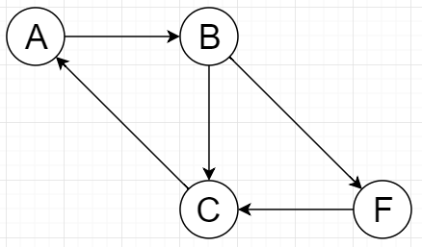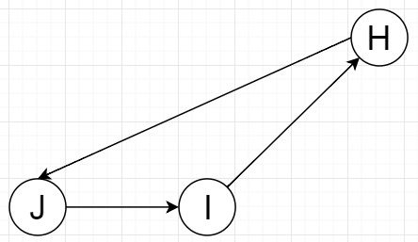

* 1. 邻接矩阵

|  |  |  |  |  |  |  |  |  |  |
| --- | --- | --- | --- | --- | --- | --- | --- | --- | --- |
| 0 | 1 | 0 | 1 | 0 | 0 | 0 | 0 | 0 | 0 |
| 0 | 0 | 1 | 0 | 0 | 1 | 0 | 0 | 0 | 0 |
| 1 | 0 | 0 | 1 | 1 | 0 | 0 | 0 | 0 | 0 |
| 0 | 0 | 0 | 0 | 1 | 0 | 0 | 0 | 0 | 0 |
| 0 | 0 | 0 | 0 | 0 | 0 | 0 | 0 | 0 | 0 |
| 0 | 0 | 1 | 0 | 0 | 0 | 0 | 0 | 0 | 0 |
| 0 | 0 | 0 | 0 | 0 | 1 | 0 | 1 | 0 | 0 |
| 0 | 0 | 0 | 0 | 0 | 1 | 0 | 0 | 0 | 1 |
| 0 | 0 | 0 | 0 | 0 | 0 | 0 | 1 | 0 | 0 |
| 0 | 0 | 0 | 0 | 0 | 0 | 0 | 0 | 1 | 0 |

* 1. 邻接表

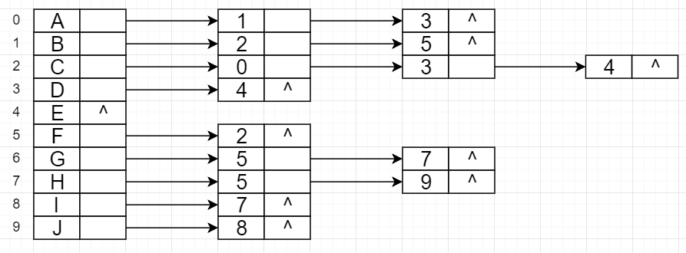

* 1. 简单回路
     1. A,B,C,A
     2. A,B,F,C,A
     3. H,J,I,H
  2. 深度优先、广度优先
     1. 深度优先序列：A,B,C,D,E,F；G,H,J,I
     2. 深度优先森林：

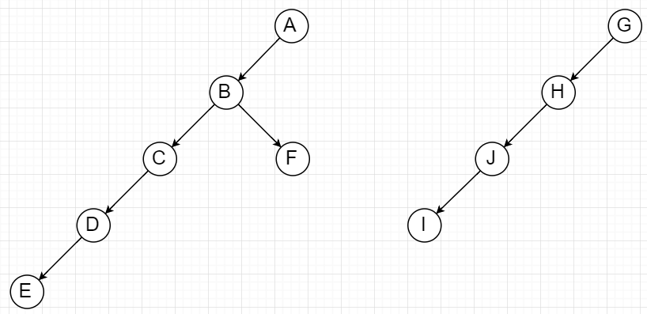

* + 1. 广度优先序列：A,B,D,C,F,E；G,H,J,I
    2. 广度优先森林：

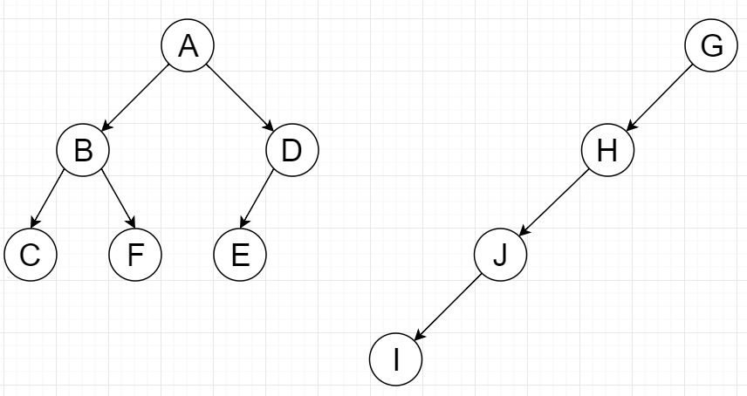

3. 答：

* 1. 深度优先搜索序列及树：A,C,B,F,G,H,I,J,E,D

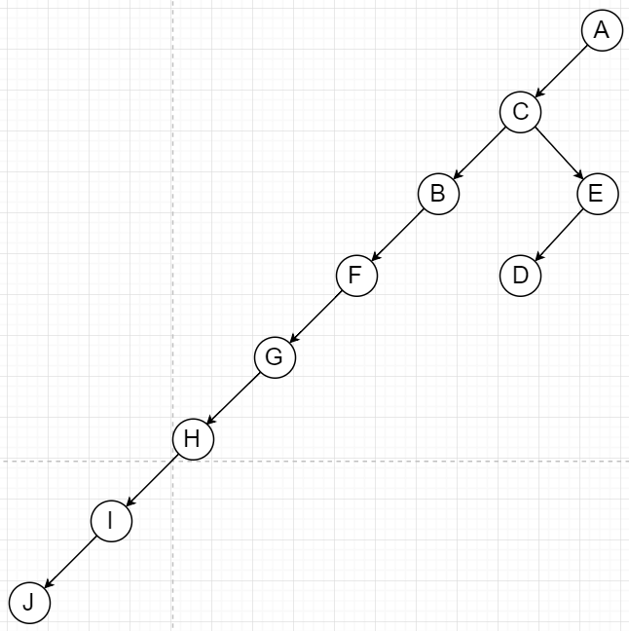

* 1. 广度优先搜索序列及树：A,C,D,B,E,F,G,H,I,J

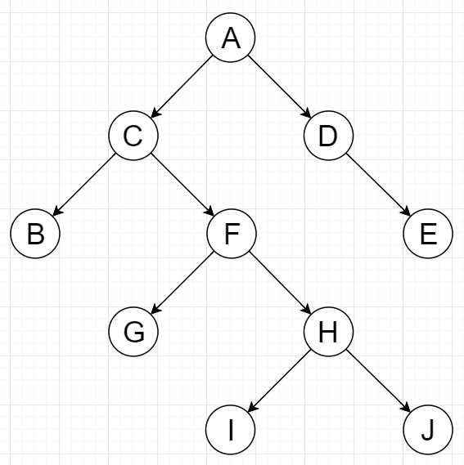

1. 答：
   1. 邻接矩阵：

|  |  |  |  |  |  |
| --- | --- | --- | --- | --- | --- |
| 0 | 4 | 6 | ∞ | ∞ | ∞ |
| ∞ | 0 | 5 | ∞ | ∞ | ∞ |
| ∞ | ∞ | 0 | 4 | 3 | ∞ |
| ∞ | ∞ | ∞ | 0 | ∞ | 3 |
| ∞ | ∞ | ∞ | ∞ | 0 | 3 |
| ∞ | ∞ | ∞ | ∞ | ∞ | 0 |

* 1. 有向加权图：

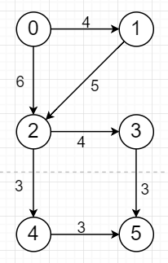

* 1. 邻接表：

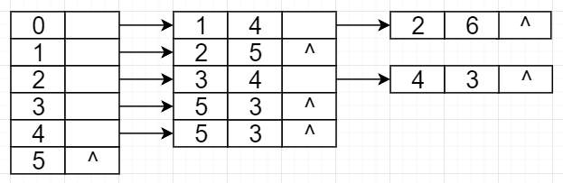

* 1. 关键路径：0,1,2,3,5，长度为16